

Foundations of Programming
Assignment No. : 10

PROBLEM STATEMENT:
Write a program in C to simulate a simple calculator that performs basic arithmetic operations such as addition, subtraction, multiplication, and division. The calculator should also perform special operations like computing xʸ (power) and x! (factorial).

OBJECTIVE:
• To understand the use of switch-case statements in C.
• To perform basic arithmetic and special mathematical operations.
• To enhance problem-solving skills using menu-driven programs.

THEORY:
A calculator is a basic computing device used to perform arithmetic operations. In C programming, a simple calculator can be implemented using conditional or switch-case statements. Arithmetic operations like addition, subtraction, multiplication, and division are fundamental operations. Special operations such as power (xʸ) and factorial (x!) require loops for repeated calculations.

PLATFORM:
Linux

ALGORITHM:

C PROGRAM:

INPUT:
User selects an operation from the menu and enters required values.
Example Input:
Choice: 1
Numbers: 10 20
CODE

#include <stdio.h>

#include <math.h>

int main() {

int choice;

double a, b, result;

int i, n;

long long fact = 1;

printf("===== Simple Calculator =====\n");

printf("1. Addition\n");

printf("2. Subtraction\n");

printf("3. Multiplication\n");

printf("4. Division\n");

printf("5. Power (x^y)\n");

printf("6. Factorial (x!)\n");

printf("Enter your choice: ");

scanf("%d", &choice);

switch(choice) {

case 1:

printf("Enter two numbers: ");

scanf("%lf %lf", &a, &b);

result = a + b;

printf("Result = %.2lf\n", result);

break;

case 2:

printf("Enter two numbers: ");

scanf("%lf %lf", &a, &b);

result = a - b;

printf("Result = %.2lf\n", result);

break;

case 3:

printf("Enter two numbers: ");

scanf("%lf %lf", &a, &b);

result = a * b;

printf("Result = %.2lf\n", result);

break;

case 4:

printf("Enter two numbers: ");

scanf("%lf %lf", &a, &b);

if(b != 0)

printf("Result = %.2lf\n", a / b);

else

printf("Error! Division by zero.\n");

break;

case 5:

printf("Enter base and exponent: ");

scanf("%lf %lf", &a, &b);

result = pow(a, b); // safer than manual loop

printf("Result = %.2lf\n", result);

break;

case 6:

printf("Enter a non-negative integer: ");

scanf("%d", &n);

if(n < 0) {

printf("Error! Factorial of negative number doesn't exist.\n");

} else {

fact = 1;

for(i = 1; i <= n; i++) {

fact *= i;

}

printf("Factorial = %lld\n", fact);

}

break;

default:

printf("Invalid choice!\n");

}

return 0;

}

OUTPUT:
Example Output:
Result = 30.00

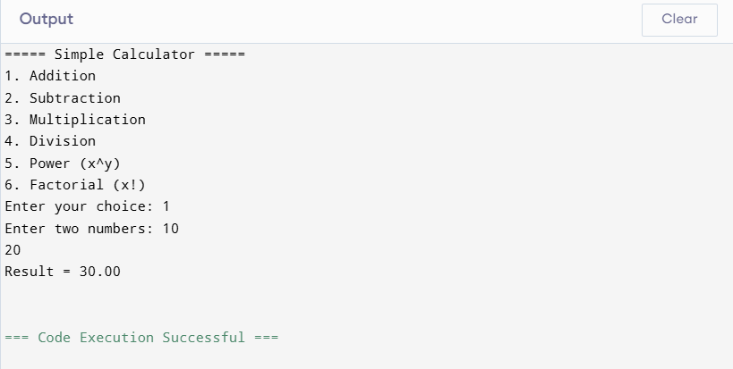CONCLUSION:
Thus, a simple calculator program was successfully implemented using C programming. The program demonstrates the use of switch-case statements, loops, and arithmetic operations.

FAQs:
- What is a simple calculator program?
- Why is switch–case preferred in calculator programs?
- How does the program handle division by zero?
- How is the power operation (xʸ) implemented without using math library functions?
- What is factorial and how is it calculated using loops in C?

